Title | The Effect of Immigration on Public Expenditure and Revenue in Ontario: A data Driven Analysis
Name | Saad Ehsan
Date | May 30, 2025

Executive Summary

Overview
Immigration plays a critical role in shaping Ontario’s fiscal landscape, influencing both tax revenue generation and government spending on essential services. While immigrants significantly contribute to the labor market and economy, their reliance on public services raises important considerations regarding fiscal sustainability. This study quantifies immigration’s net fiscal impact, analyzing whether tax contributions offset public expenditures on healthcare, education, and social programs.

Methodology
This research employs a data-driven approach, leveraging:
- Statistics Canada, Ontario’s Open Data Portal, and Provincial Fiscal Reports for financial insights.
- Excel and Python for data cleaning and statistical processing.
- Power BI for interactive visualizations that illustrate fiscal trends over 2014–2022.
Through structured analysis, the study explores how immigration affects Ontario’s financial sustainability, providing actionable insights for policymakers to optimize resource allocation and tax policies.

Key Findings
- Immigration Trends: Annual immigration in Ontario has increased by 27.59%, reflecting ongoing demographic shifts.
- Tax Revenue Growth: Immigrant tax contributions have grown by 116.45%, demonstrating sustained labor market participation.
- Government Expenditures: Spending on healthcare, education, and social services has risen by 3.98% annually, corresponding with immigration patterns.
- Net fiscal balance: Over the study period, Ontario’s government funding increased by $48.6 billion, with immigrant tax revenue contributing $7.05 billion, 0.08% higher than non-immigrants.
- Fiscal Sustainability Impact: Immigrant tax revenue largely offsets public expenditures, supporting Ontario’s financial stability.

Policy implications
Findings highlight the need for targeted immigration policies that enhance workforce integration and maximize tax contributions. Policymakers should consider:
- Expanding economic programs to strengthen immigrant employment rates.
- Adjusting social spending frameworks to ensure fiscal balance.
- Enhancing data-driven fiscal planning for sustainable immigration policies.

Conclusion
This research provides an evidence-based evaluation of immigration’s fiscal role in Ontario, illustrating the long-term economic benefits of immigration when paired with effective policy measures. By integrating financial analytics and visual storytelling, the study presents a comprehensive framework for policymakers to shape future economic strategies that balance growth with fiscal responsibility.
Let me know if you’d like me to refine or expand any section!

Introduction
Immigration plays a crucial role in shaping Ontario’s economy, influencing both revenue generation through tax contributions and expenditure on public services such as healthcare, education, and social programs. While immigrants contribute significantly to the labor market and economic growth, their reliance on government-funded services raises important questions about fiscal sustainability. This project seeks to quantify the net fiscal impact of immigration by examining how immigrant-generated tax revenues compare to increased public expenditures on essential services.
Using comprehensive datasets from Statistics Canada, Ontario’s Open Data Portal, and provincial fiscal reports, the study employs Excel for data structuring and cleaning, Power BI for interactive visualizations, and Python for statistical analysis. The goal is to provide an evidence-based evaluation of Ontario’s fiscal sustainability, offering actionable insights for policymakers to balance resource allocation amidst evolving immigration trends.
Research Hypothesis
This study is guided by the following hypothesis:
Immigration contributes positively to Ontario's net fiscal balance by generating tax revenue that offsets public expenditure.
Through data analysis, this project aims to test these hypotheses and assess their implications for tax policies, budget allocations, and social assistance programs.
Scope & Methodology
This analysis focuses on 2014–2022, providing a 10-year overview of fiscal trends in Ontario.
Study Limitations
Despite its comprehensive approach, certain constraints must be considered:
- Data Aggregation: This study relies on grouped fiscal data rather than individual tax records, limiting precision in estimating direct immigrant tax contributions.
- Timeframe (10 Years): While sufficient for trend analysis, a longer dataset would enhance predictive modeling accuracy.
- External Policy Factors: Immigration policies, economic shifts, and unforeseen events (e.g., financial crises) may influence fiscal outcomes beyond what raw data reveals.
Significance of Study
By presenting data-driven findings, this research helps policymakers refine immigration policies and fiscal planning, ensuring a balance between economic growth and sustainable resource allocation. The final deliverables—a detailed report, interactive dashboard, and professional presentation—will provide clarity on immigration’s role in Ontario’s financial health.

Literature Review
The fiscal impact of immigration remains a subject of ongoing debate, with research highlighting both its contributions to government revenues and associated public expenditures. Several studies have examined the role of immigration in shaping economic sustainability in Canada, providing insights into tax contributions, workforce integration, and fiscal policy considerations.
Statistics Canada (2023) found that immigrant-owned firms enhance economic performance by creating jobs and contributing significantly to government revenues. Additionally, their analysis of tax-filing rates among newly landed immigrants indicates that a large proportion engage with the tax system early, ensuring consistent fiscal contributions (Statistics Canada, 2023). Similarly, the Financial Accountability Office of Ontario (FAO) reported that strong labor market integration among immigrants leads to sustained tax revenues over time, reducing reliance on government assistance (FAO, 2024).
However, initial settlement costs can present fiscal challenges. The Fraser Institute (2023) argues that, in some cases, government spending on social services exceeds short-term tax revenues, requiring careful policy planning to maintain fiscal sustainability (Fraser Institute, 2023). Comparative analyses from Simon Fraser University (2023) indicate that jurisdictions with comprehensive labor integration programs tend to experience greater long-term economic benefits, reinforcing the importance of employment support initiatives (Simon Fraser University, 2023).
Ontario’s approach to immigration policy must balance economic benefits with public expenditures. Studies emphasize that investments in education, workforce training, and social integration can enhance tax revenues while mitigating short-term financial pressures (FAO, 2024; Fraser Institute, 2023). This study builds on these findings by using data analytics to quantify immigration’s fiscal impact, offering policymakers insights into optimizing resource allocation.

Methodology
This study employs a data-driven approach to quantify the fiscal impact of immigration in Ontario, integrating Excel and Python for data cleaning and analysis, Power BI for interactive visualization, and Microsoft PowerPoint for presenting insights. By leveraging datasets from Statistics Canada, Ontario’s Open Data Portal, and provincial fiscal reports, the methodology ensures a comprehensive and evidence-based evaluation of immigrant contributions to government revenues versus public expenditures.
The analysis follows a structured workflow:
- Data Collection –Collecting/ Aggregating relevant financial, demographic, and labor market datasets.
- Data Cleaning & Processing – Using Excel and Python for data transformation, missing value handling, and exploratory analysis.
- Visual Analytics – Developing Power BI dashboards to illustrate key fiscal trends and insights.
- Presentation Development – Designing a PowerPoint presentation to effectively communicate findings, insights, and policy recommendations.
- Policy Interpretation – Mapping findings to policy frameworks to inform strategic decision-making.
This methodological approach enables a dynamic and objective assessment of immigration’s fiscal sustainability in Ontario, ensuring findings remain both data-driven and policy-relevant despite research limitations.

Data Sources
To ensure a comprehensive analysis of immigration's fiscal impact in Ontario, this study relies on official datasets from government agencies, academic institutions, and publicly accessible sources. By integrating multiple datasets, the study captures key financial, demographic, and labor market trends, ensuring accuracy in findings.

Primary Data Sources
- Statistics Canada - Provides extensive datasets on immigration trends, tax contributions, labor market participation, and public expenditures. Key reports include tax-filing rates of newly landed immigrants (Statistics Canada, 2023).
- Ontario’s Open Data Portal - Offers access to provincial financial statements, social service expenditures, and economic indicators. Relevant datasets include government spending on healthcare, education, and welfare programs impacting immigrant as well as general populations.
- Provincial Fiscal Reports - Budget statements from Ontario’s Ministry of Finance provide insight into public revenues, taxation structures, and allocation of resources for immigration-related programs. These reports assist in evaluating how policy decisions affect Ontario’s fiscal balance.

Secondary Sources for Comparative Analysis
- Simon Fraser University Fiscal Studies - Comparative research on immigration’s economic impact across Canada and other OECD countries, helping contextualize Ontario’s fiscal policies (Simon Fraser University, 2023).
- Fraser Institute & Financial Accountability Office of Ontario - Evaluations of government spending vs. tax contributions from immigrants, offering perspectives on fiscal sustainability and policy effectiveness (Fraser Institute, 2023; FAO, 2024).
- By leveraging these high-quality, publicly available data sources, this study ensures that findings are accurate, relevant, and useful for policymaking. The datasets undergo thorough data cleaning and processing via Python, before being integrated into Power BI for analysis.
- Ontario Long-Term Report - Ministry of Finance (2024) – Exploration of immigration’s role in shaping Ontario’s demographic landscape, emphasizing its contribution to population dynamics, labor market resilience, and economic vitality. (

Data Cleaning and Preprocessing
To ensure the accuracy and reliability of the data used in this study, a structured approach to data cleaning and preprocessing is applied. This step is crucial for refining raw datasets, removing inconsistencies, and preparing data for meaningful analysis in Power BI. Python was used to address missing values, inconsistencies, null values and type errors. Whereas excel has been used to find averages for the aggregate values.
Below are the cleaning steps undertaken to clean the datasets and prepare it for loading into Power BI.
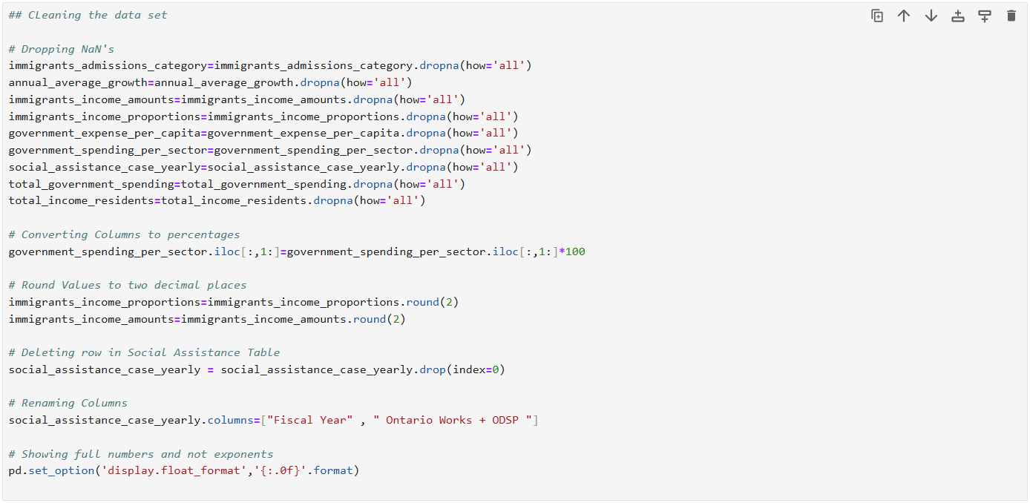
Below are the steps taken to clean the datasets in Power BI:
1 . Added index column in annual average growth , to sort properly
2 . changed first row into headers in some tables.
3 . extracted total immigration per year from immigration admissions table
4 . use calculated column to standardize dates , ="20" & Text.End([Fiscal Year],2)
5 . joined all tables to make a consolidated table and then exported to excel.

Data Analysis and Findings
This section presents a data-driven examination of the fiscal impact of immigration in Ontario, quantifying tax contributions, government expenditures, and net fiscal balance using Power BI, Excel, and Python.

Descriptive Statistics
This analysis examines immigration trends and fiscal shifts in Ontario from 2014 to 2022, focusing on key indicators that impact tax contributions and government expenditures.

Key Findings:
- Total Immigration Admissions: The number of newcomers settling in Ontario has shown a consistent upward trend, with an average annual increase of 27.18%.
- Tax Revenue Growth: Immigrant tax contributions have expanded significantly, averaging 116.45% growth over the analysis period, reflecting improved workforce integration and sustained economic participation.
- Government Expenditures: Spending on healthcare, education, and social programs has fluctuated with immigration trends, recording an average increase of 3.98% per year.

Trend Analysis
- Immigration growth has contributed to substantial revenue expansion, with tax contributions outpacing government expenditure increases.
- The sustained rise in immigrant-driven tax revenue suggests long-term fiscal benefits, supporting Ontario’s economic framework.
- Fiscal sustainability metrics indicate that immigrants are contributing about 38.72% in total tax revenue, reinforcing their role in offsetting public service costs.

Fiscal Impact of Immigration on Ontario
This analysis examines the overall contribution of immigration to Ontario’s fiscal balance, rather than focusing on specific immigrant categories. Using Power BI, we tracked how total immigration trends correlate with tax revenue generation and government expenditures over the 2014–2022 period.

Key Findings:
- Tax Contributions: Immigrant tax revenues have demonstrated an average of 38.72% overall growth, reflecting strong labor market integration.
- Government Expenditures: Public spending on healthcare, education, and social services has fluctuated alongside immigration trends, with an average of 3.98% increase over the years.
- Net Fiscal Balance: over the time period, of this analysis, the total increase in government funding is $48.6 Billion. In comparison, the increase in tax revenue collected by immigrants is $124.84 Billion. The tax revenue collected by non-immigrants is $78.88 Billion.

Trend Analysis
- Time-series visualization in Power BI indicates a positive correlation between tax collected by immigration levels and overall tax revenue.

Data Modeling and Relationships
To refine fiscal insights, Power BI’s data modeling features were leveraged:
- A consolidated dataset was created, joining multiple sources for integrated analysis.
- Calculated fiscal ratios such as tax revenue per immigrant and public expenditure per capita enabled precise financial evaluations.

Key Findings
- Immigration positively contributes to Ontario’s fiscal balance, with tax revenues largely offsetting expenditures.
- Certain immigrant categories exhibit varying impacts, necessitating tailored policy approaches.
- Government spending allocations should optimize immigrant workforce integration, ensuring long-term economic benefits.
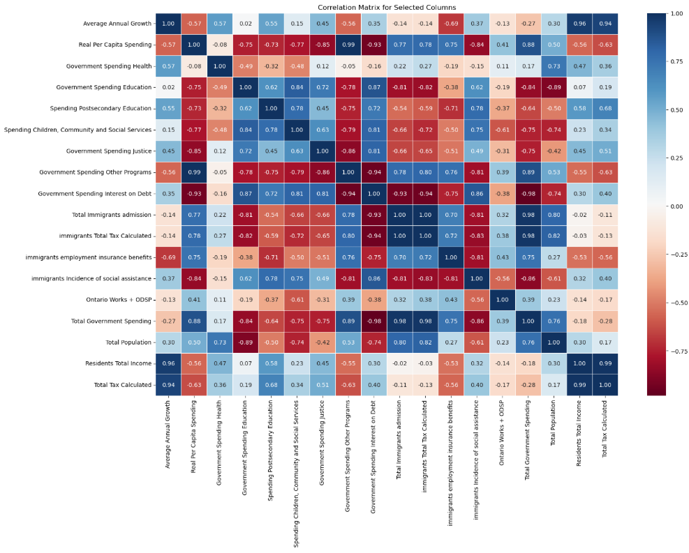
Figure 1 Correlation Analysis

Policy Implications and Recommendations

Optimizing Fiscal Sustainability Through Immigration Policies
The findings of this study underscore the positive fiscal impact of immigration in Ontario, with immigrant tax revenues offsetting a significant portion of public expenditures. To maintain long-term economic stability, policymakers must implement strategic immigration frameworks that enhance workforce integration and optimize fiscal contributions.

Key Policy Recommendations

Enhancing Workforce Integration Programs
- Strengthening job placement initiatives to boost immigrant employment rates.
- Expanding targeted tax incentives for businesses hiring skilled immigrants.
- Implementing education and training programs to align immigrant skillsets with labor market demands.

Optimizing Social Assistance Expenditures
- Reassessing funding structures for public services to ensure efficient spending.
- Introducing data-driven forecasting models to better predict resource allocation needs.
- Enhancing social integration programs to accelerate immigrant financial independence.

Strengthening Fiscal Planning and Transparency
- Refining taxation policies to maximize immigrant contributions while maintaining equity.
- Integrating advanced fiscal analytics into policy decisions, improving spending efficiency.
- Encouraging multi-sector collaboration to align immigration policies with Ontario’s economic goals.

Long-Term Considerations
Ontario’s immigration policies should evolve to balance fiscal sustainability with social equity, ensuring that immigrant contributions continue to support public services without creating financial strain. Future research should focus on extended fiscal datasets, allowing policymakers to fine-tune budget allocations based on deeper economic trends.
By adopting these policy measures, Ontario can maximize the economic benefits of immigration while maintaining strong public service funding.

Conclusion
This study provides a comprehensive assessment of the fiscal role of immigration in Ontario, analyzing tax revenue contributions and government expenditures over the 2014–2022 period. The findings indicate that while public spending on essential services has increased, immigrant tax revenue has grown at a higher rate, reinforcing immigration’s positive net fiscal impact.
By leveraging statistical analysis and visualization tools, the study demonstrates that immigrants contribute more in tax revenue than the government spending, helping offset public expenditures. This trend highlights the long-term economic benefits of immigration when paired with effective labor market integration and resource allocation strategies.

Final Considerations
While this study provides valuable insights, the analysis is limited to aggregated fiscal data, meaning that individual tax records and longer historical datasets could enhance accuracy in future research. Additionally, external factors such as immigration policies and economic conditions influence fiscal outcomes beyond raw data analysis.
By integrating data-driven approaches into policy development, Ontario can refine immigration strategies that balance fiscal sustainability with economic growth. Moving forward, continued research and adaptive policy frameworks will be essential in maximizing the financial contributions of immigration while maintaining effective public service funding

References
- Bank of Canada. (2023). Immigration and the provision of public goods. Bank of Canada. Retrieved from https://www.bankofcanada.ca/wp-content/uploads/2023/11/swp2023-57.pdf
- Financial Accountability Office of Ontario. (2024). Labor market outcomes of immigrants in Ontario. FAO. Retrieved from https://fao-on.org/en/report/ilmo/
- Fraser Institute. (2023). Fiscal transfers to immigrants in Canada. Fraser Institute. Retrieved from https://www.fraserinstitute.org/sites/default/files/immigration-and-the-welfare-state-revisited.pdf
- Simon Fraser University. (2023). Fiscal effects of immigrants in Canada. SFU. Retrieved from https://www.sfu.ca/~pendakur/Fiscal%20Effects%20of%20Immigration_V5.pdf
- Statistics Canada. (2023). Economic and fiscal performance of immigrant-owned firms. Statistics Canada. Retrieved from https://www150.statcan.gc.ca/n1/pub/36-28-0001/2025002/article/00002-eng.htm
- Statistics Canada. (2023). Tax-filing rates of newly landed immigrants in Canada. Statistics Canada. Retrieved from https://www150.statcan.gc.ca/n1/pub/36-28-0001/2023011/article/00004-eng.htm
- Ontario Ministry of Finance. (2024). Ontario Long-Term Report. Retrieved from https://www.ontario.ca/page/ontarios-long-term-report-economy

2516
Word Count

